Solar Powered Battery Charging With Reverse Current Protection

Solar energy is a very efficient source of green energy that is available for free. But it needs to be coupled with proper storage for best use. Also to store it we need to use charge controlling circuitry to protect panel from reverse currents as well as to charge the battery efficiently. So we demonstrate this concept by using a mini solar panel to charge a rechargeable pencil cell battery. Also we use a charge control circuit designed to stop reverse current flow and charge the battery effectively using the solar panel. Thus this allows us to effectively provide solar battery charging with reverse current protection.

Block Diagram :
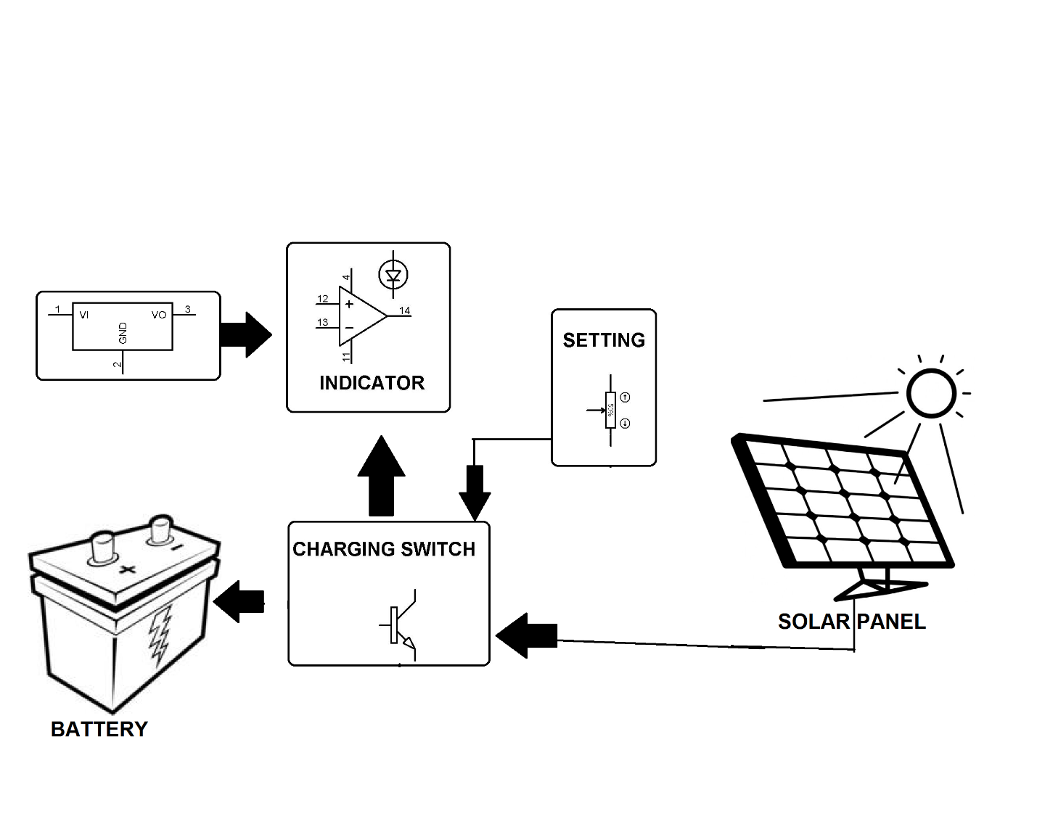

Hardware Specifications
- 3W Solar Panel
- AA Rechargeable Battery
- Resistors
- Capacitors
- Diodes
- Charging Switch
- Connectors

